CPT202

Assignment 2

Individual Report

Xingbo Wei

1824150

Group [23]

[Developer]

Table of Contents

Personal Project Summary 2

Personal Reflections on Projects 2

Contributions to the Project 2

Summary of Lessons Leant 3

References 3

# Personal Project Summary

Chuangsen is our sponsor of this coursework, this company want us to develop an app about booking gymnasium courts which is convenient for client to booking court and company to manage the gym. WeChat Mini Program is a trend of the application development, it is an application that does not need to download, and easiness to control the background for clerk[1]. That why we choose this way to develop. For development successfully we chose agile software development as our developing methods, it requires the developer to intimate links with the product owner, and it is efficiently, quickly and high customer satisfaction. But, all of us are a novice for the developer and we encountered a bottleneck in the development process, I will evaluate and analyze these issues later. When this app is official launch, ChuangSen can profit from this app. Not only for Chuangsen but our team also ‘profit’ from this software development. As a developer in our team, the ability of JavaScript coding is multiplied rapidly, and learn how to construct the struct of the database, in this project I present the number list and how to connect the database with the user interface. But I think the most important things I learned how to cooperate with other developer using azure and confer with the scrum master product owner, because developing a program not complete by one person, co-development is the only way to develop a program. next, I will critical of the project management and development process.

# Personal Reflections on Projects

We divide our project into four parts, UI design, Front-end, Back-end and Database. All of the processes are completely before sprint 3, we plan to construct the database and connect it with the servers, the first difficult problem is what is the suitable container for store the user info and court status in the case of Chuangsen don’t give us any database information. Initially we analyze the count of user’s information such as name, phone number, order information and court status. Unfortunately, we don’t consider which items can be used as a certificate to log in. We initially consider the Wechat UUID[2] as the user identity to log in and as the primary key to store in the database. But I deny this scheme because it does not satisfy the Do Not Surprise the User design principle, because when using access this Wechat Mini Program the first time who cannot find registered or log inbox, it will confuse the user. Consider that, we design a log in the entrance, after login, the page will show the user Wechat profile photo. Apply this design will satisfy the Provide Feedback design principle.

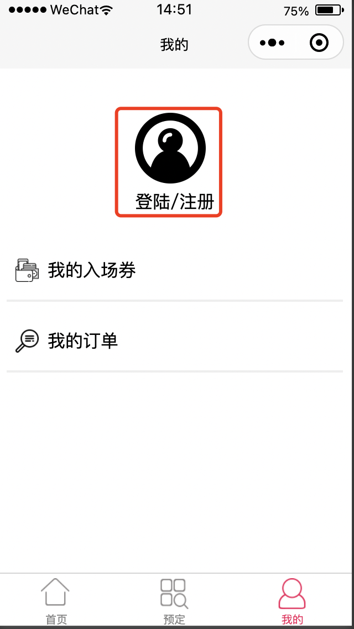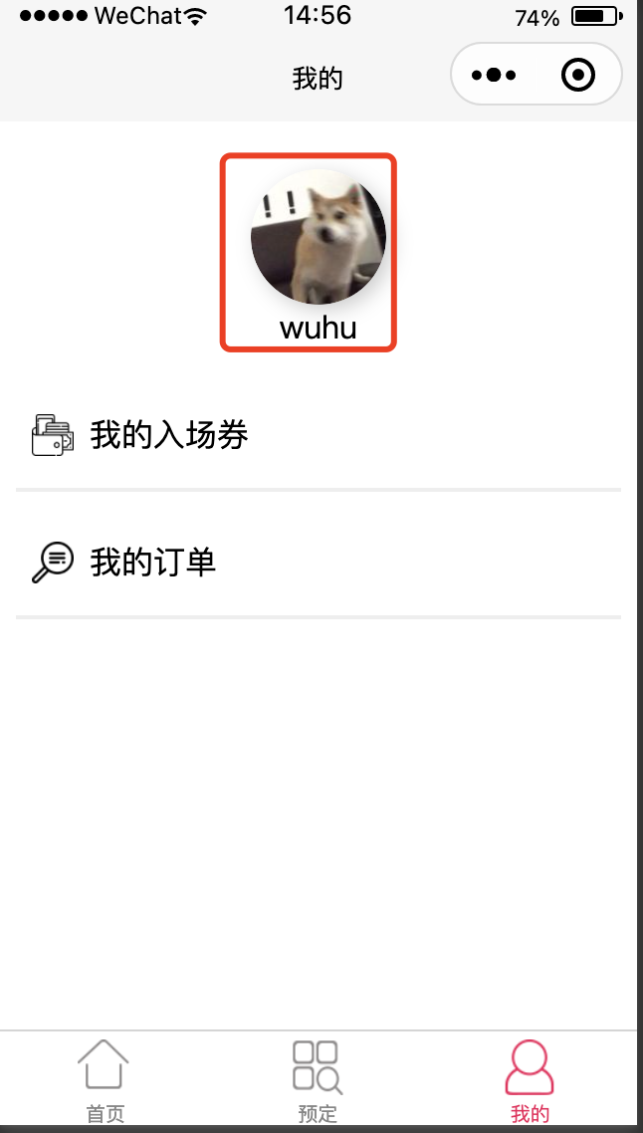

[pic1] [pic2]

Finished this sprint, we invite five students as a volunteer to test this mini-program use usability evaluation methods. volunteer experience our the alpha version and write our questionnaire, we set three questions, if this app easy to accomplish register the first time? How quickly to accomplish booking court? How pleasant to use the design? All of the volunteers give a positive comment. Although the UUID I mentioned above is not used in the id identify the key in the login function, but it important for order identify the primary key, next I will why it is important and give more detail about what I responsible for this program.

# Contributions to the Project

I am responsible for the database design and connect it with back-end. we can’t recognize order, because it has a lot of order items in the database. This time, I apply UUID to identify the order, use this identify method, every items has _id(UUID) in the order list. When user register a count, back-end will add user information, meanwhile, it will create a UUID store into this item. When user booking a court, the order information will add UUID into database item. In this way, we solve the problem that order item don’t know who belongs to.

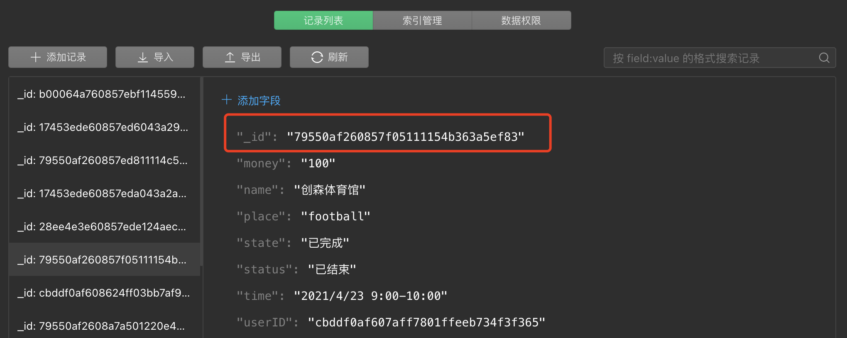

# Summary of Lessons Leant

In this group project, all of the members are the first time to contribute a real application. For me, the level of coding has been improved rapidly, as a developer communication is crucial, you have to read other member’s code and write a low coupling code to coinvent other developers to call the special method which you write. The version control is also important so we use git to manage our version, a real app development process is complex, we don’t not which version is suitable so we need to continually evaluate every function. Continue to evaluate it means you should connect with other developers, connect with the product owner and scrum master, that why I think communication is most important. A real program is not one person’s task, it should cooperate with other members. In feature development, I think the first things is to write a complete software document and continuously adjust after communication. The second things is to read official document, finally and most important: communication with others developer.

# References

[1] Tencent. ”WeChat-Mini-Program Development Guide”. Weixin public doc. <https://developers.weixin.qq.com/miniprogram/en/dev/framework/>(2016.9.21)

[2] https://opensource.apple.com/source/CF/CF-299.35/Base.subproj/uuid.c.auto.html